TEE CHEMISTRY
Semester 1 Examination 2002
SOLUTIONS

Part 1

1. d | 6. c | 11. a | 16. d
2. a | 7. b | 12. b | 17. d
3. b | 8. d | 13. b | 18. d
4. b | 9. a | 14. c | 19. c
5. d | 10. b | 15. b | 20. a

Part 2

1.
a) Equation Fe(s) + 2H⁺(aq) → Fe⁺²(aq) + H₂(g)
Observation Bubbles of colourless gas evolve. The solid dissolves. The solution may be pale green.

b) Equation NiCO₃(s) + 2OH⁺(aq) → Ni⁺² (aq) + H₂O(e) + CO₂(g)
Observation Effervescence releases colourless bubbles of gas. The solid dissolves. The final solution is green.

c) Equation Mn⁺²(aq) + 2OH⁻(aq) → Mn(OH)₂(s)
Observation The two colourless solutions when mixed result in a white precipitate.

d) Equation Zn(OH)₂(s) + 2OH⁻ (aq) → [Zn(OH)₄]⁻² (aq)
Observation The white powder dissolves to form a colourless solution.

2.
Species | Electron dot diagram | Draw the shape showing all atoms
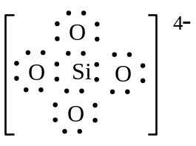
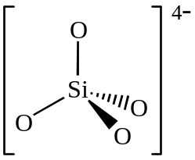
Ortho silicate ion
SiO₄⁻⁴

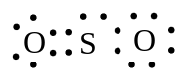
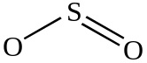
Sulfur dioxide
SO₂
3. (a) The end point is the point at which an indicator changes colour. The equivalence point is the point at which chemically equivalent amounts of acid and base have been combined.

(b) A dilute acid is one having more water than acid present. It has less acid than a more concentrated acid in solution. It may be a strong or a weak acid. A weak acid is only partially ionised in aqueous solution. Most of it is as molecules in solution.

4.

Enthalpy
E_{A} = 4

ΔH = 1

Progress of reaction

400

300

200

100

0
Enthalpy
(kJ mol⁻¹)
Uncatalysed

Catalysed

ΔH = 120 kJ mol⁻¹

Progress of reaction

5.
- The Na₂CO₃ is of high purity and stable during the weighing process so its mass can be determined accurately.
The NaOH is unstable – it absorbs CO₂(g) and H₂O(e) from the air – so its mass cannot be accurately measured.

- Name: Methyl Orange

Colour change: From yellow/orange to pink/red

- At equivalence point hydrolysis makes the strong acid (HCl) and weak base (sodium carbonate) solution acidic. We choose methyl orange since it changes colour in the acid range and minimised titration error.

6.
Compound name | Formula | Aqueous solution would be Acidic/Basic/Neutral?
Potassium sulfate | K₂SO₄ | basic
Ammonium chloride | NH₄Cl | acidic
Sulfur dioxide | SO₂ | acidic
Sodium ethanoate | CH₃COONa | basic

7.
Name of solid | Bonding type
graphite | CN
lead | M
calcium carbonate | I
ice | CM

8.
Aqueous solution | strong electrolyte | weak  electrolyte | non  electrolyte
Sodium carbonate
ethanoic acid
barium chloride
ammonium ethanoate
sucrose (sugar)
water

Part 3

1.
- n (AgC) = 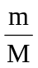=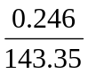 = 1.72 10⁻³ mol [M AgC = 143·35]

- C⁻(aq) + Ag⁺(aq) AgC (s)

n(NaC) = n(C⁻) = n(Ag⁺) = n(AgC) = 1·72 10⁻³ mol

- n (NaC) _{in 250·0 mL} = 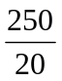 n (NaC_{) in 20 mL} = 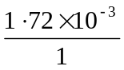= 2·15 10⁻² mol

- All the NaC in 250·0 mL came from the 14·962g sample. So

[M NaC = 58·44]

m(NaC) _{in sample} = M n(NaC) _{in 250 mL} = 2·15 10⁻² 58·4 = 1·26g

- % NaC by mass = 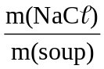 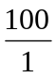 = 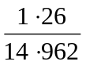 = 8·42%

2. n(C) = n(CO₂) = = 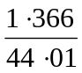 = 0·0310 mol
m(C) = n M = 0·0310 12·01 = 0·3723g

H⁺ + OH⁻ H₂O

n (C) = n(H⁺) = n (OH⁻) = c V = 2·007 29·12 10⁻³ = 0·05844 mol
m(C) = n M = 0·05844 35·45 = 2·0717 g

m(F) = m(sample) – (m(C) + m(C) = 3·034 - 2·444 = 0·59 g

n(F) = = 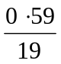 = 0·0311 mol

 | C | C | F
mols | 0·0310 | 0·05844 | 0·0311
smallest ratio | 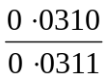 = 0·997 | 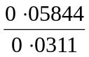 = 1·88 | 1
 | 1 | 2 | 1
E F = CC₂F

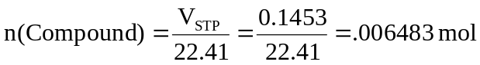
M(Compound) =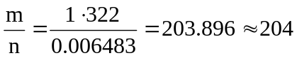 g mol⁻¹

M(CC₂F) = 101.91 g mol⁻¹

molecular formula = 2 Empirical formula

= C₂C₄F₂

3. (a) find V(N₂) at S.T.P.

P₁ = 96·0 kPa P₂ = 101·3 kPa
V₁ = 1·728 L V₂ =?
T₁ = 298 K T₂ = 273 K

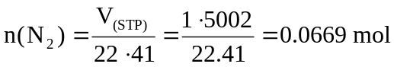
m(N₂) = n M = 0·0669 28·02 = 1·87 g

(b) find n(N₂ + CO₂)
n(N₂ + CO₂) = 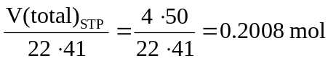
n(CO₂) = n(N₂ + CO₂) – n(N₂) = 0·2008 - 0·0669 = 0·1339 mol

from the equation n(CaCO₃) = n(CO₂) = 0·1339 mol
m(CaCO₃) = n M = 0·1339 100·09 [M(CaCO₃) = 100·09 g mol⁻¹]
= 13·4g

4. (a) n(Na₂CO₃) = = 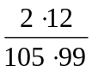 = 0·02 mol
n(Cu(NO₃)₂) = c V = 1·00 10⁻² = 0·01 mol [M Na₂CO₃ = 105·99 g mol⁻¹]

Cu⁺²(aq) + CO₃⁻²(aq) CuCO₃(s)

from equation n(Cu⁺²) = 1
n(CO₃⁻²) 1
L.R is Cu⁺² (Cu(NO₃)₂)
from data n(Cu⁺²) = 1
n(CO₃⁻²) 2

(b) from equation n(CuCO₃) = n (Cu⁺²) = 0·01 mol
mCuCO₃ = n m = 0·01 123·56 [M(CuCO₃) = 123·56 g mol⁻¹]
= 1·24g
(c) CuCO₃(s) + 2H⁺(aq) CuSO₄(aq) + H₂O() + CO₂ (g)

nCuSO₄ · 5H₂O = n(CuSO₄) = n(CuCO₃) = 0·01 mol
[M(CuSO₄ · H₂O) = 249.69 g mol⁻¹]
m(CuSO₄ · 5H₂O) = n M = 0·01 249·69 = 2·4969 g

For 90% recovery m(CuSO₄ · 5H₂O) = 2·4969 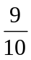 = 2.25 g

